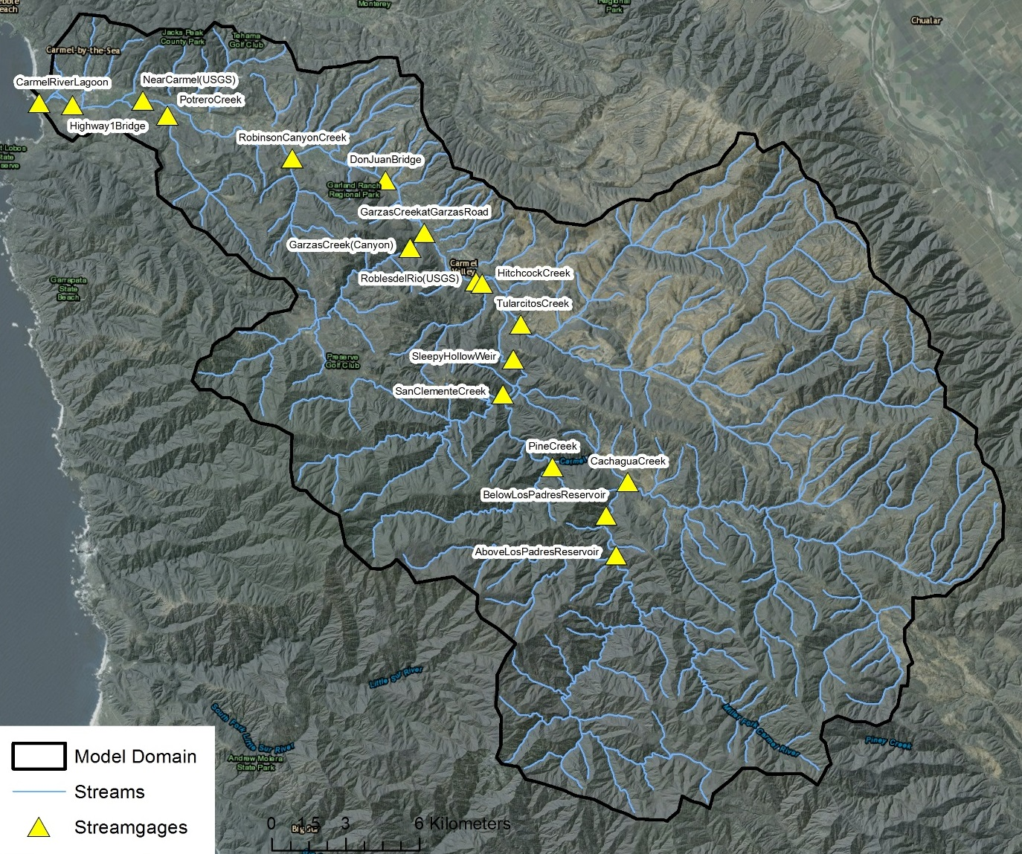

Figure 1. Model domain, streams, and streamgages of the Carmel River study area.

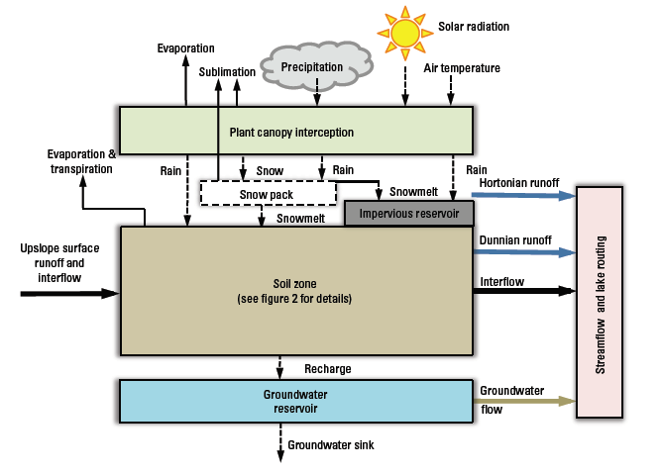

Figure 2. Overview of the Precipitation-Runoff Modeling System model components and conceptualization of Hydrologic Response Unit (HRU) states and fluxes (modified from Markstrom et al., 2015).

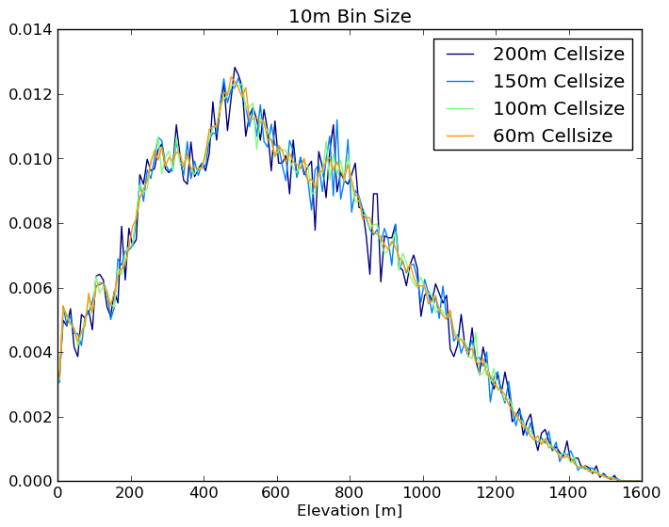

Figure 3. Probability Density Function (PDF) graph of grid elevation for various grid resolutions, where the 100 m resolution follows the finer 60 m resolution distribution, and there is a relatively large change at 150 m and 200 m resolutions.

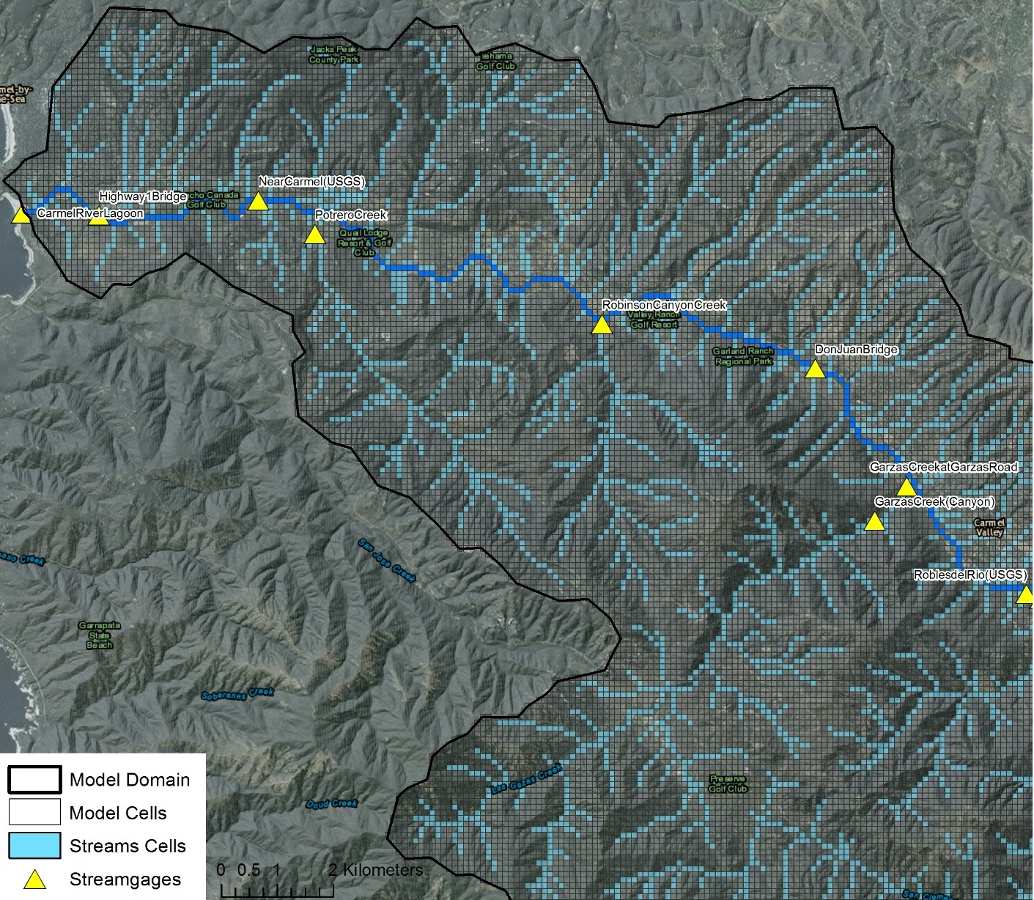

Figure 4a. Model domain and 100 m model grid and stream cells of the lower Carmel River basin.

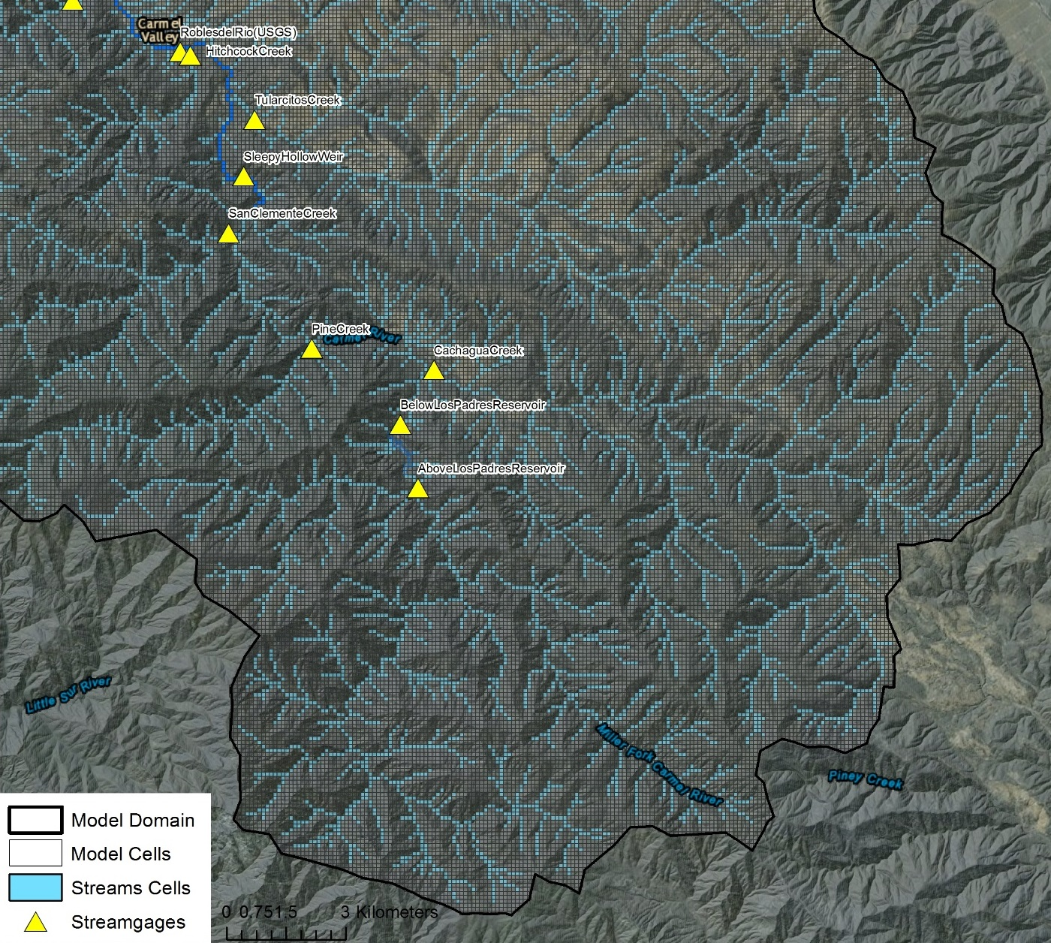Figure 4b. Model domain and 100 m model grid and stream cells of the upper Carmel River basin.

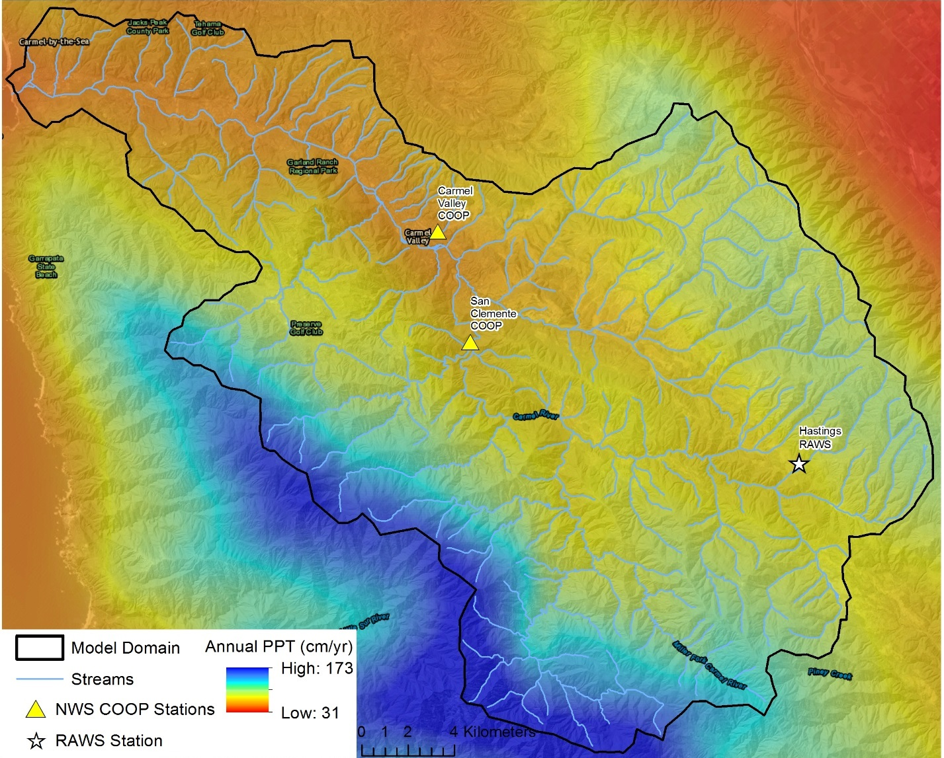

Figure 5. Spatial distribution of PRISM mean annual (1981-2010) precipitation mapped to 100 m model grid cells, and climate stations used to distribute precipitation and temperature, and calibrate precipitation, solar radiation, and potential ET module parameters. The PRISM annual precipitation distribution highlights that the majority of precipitation falls at high altitudes near the southern watershed boundary.

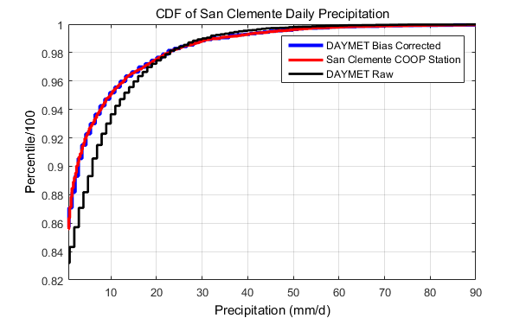

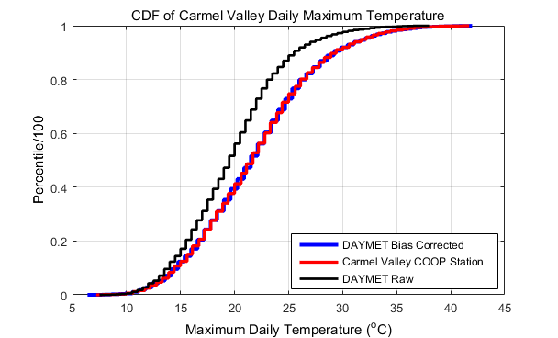

Figure 6. Cumulative distribution functions (CDFs) of raw DAYMET, station measurements, and bias corrected DAYMET estimates of daily precipitation (top) and maximum temperature (bottom). Bias corrections of DAYMET and Maurer daily precpitation and maximum and minimum temperature were performed using the CDF quantile-quantile mapping technique.

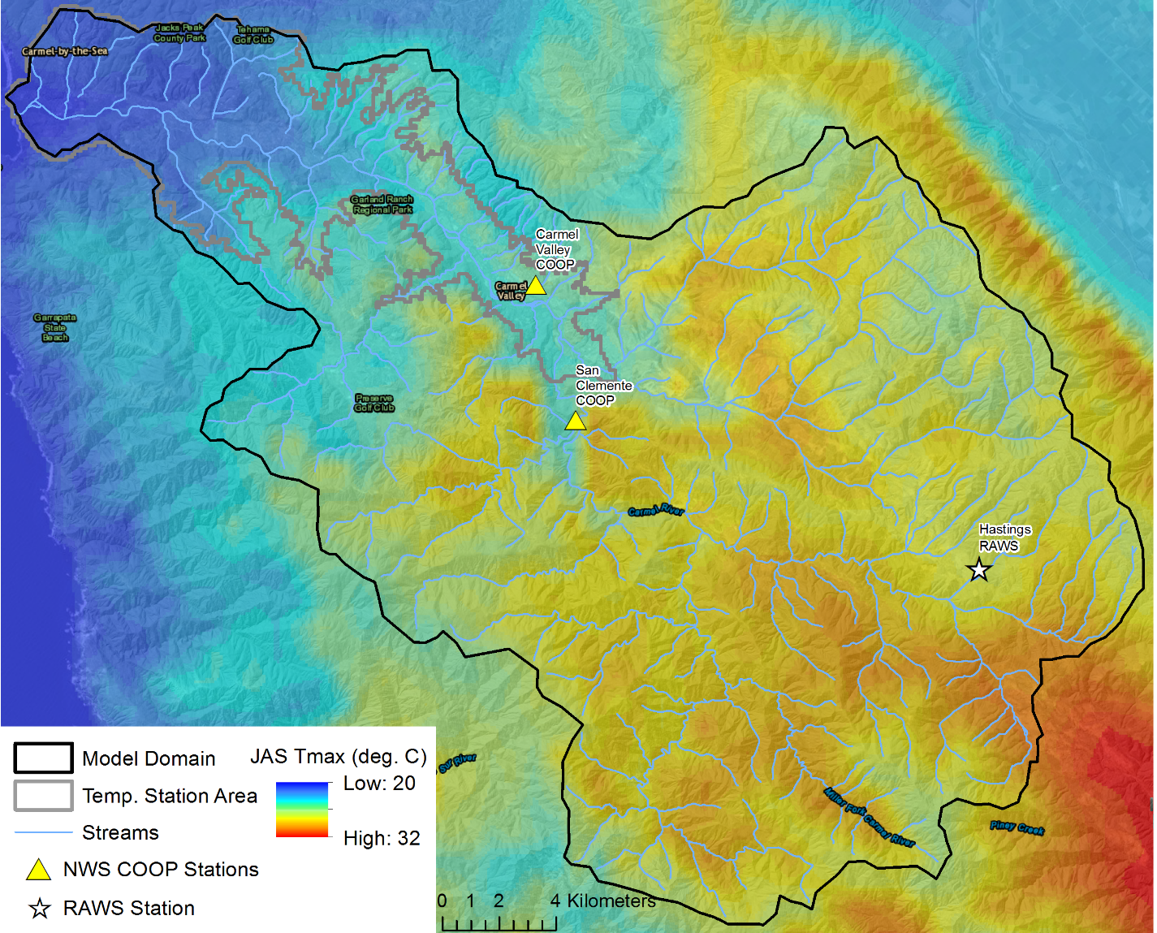

Figure 7. Spatial distribution of PRISM July, August, September (JAS) monthly average maximum temperature (for the period 1981-2010) mapped to 100 m model grid cells, and climate stations used to distribute temperature (Carmel Valley COOP and Hastings RAWS). The grey temperature station area illustrates the area in which the Carmel Valley COOP station is used to distribute temperature, where the Hastings RAWS station is used to distribute temperature for the remaining model area (upland areas). The PRISM mean JAS temperature distribution highlights summer temperature inversions that are common within the study area.

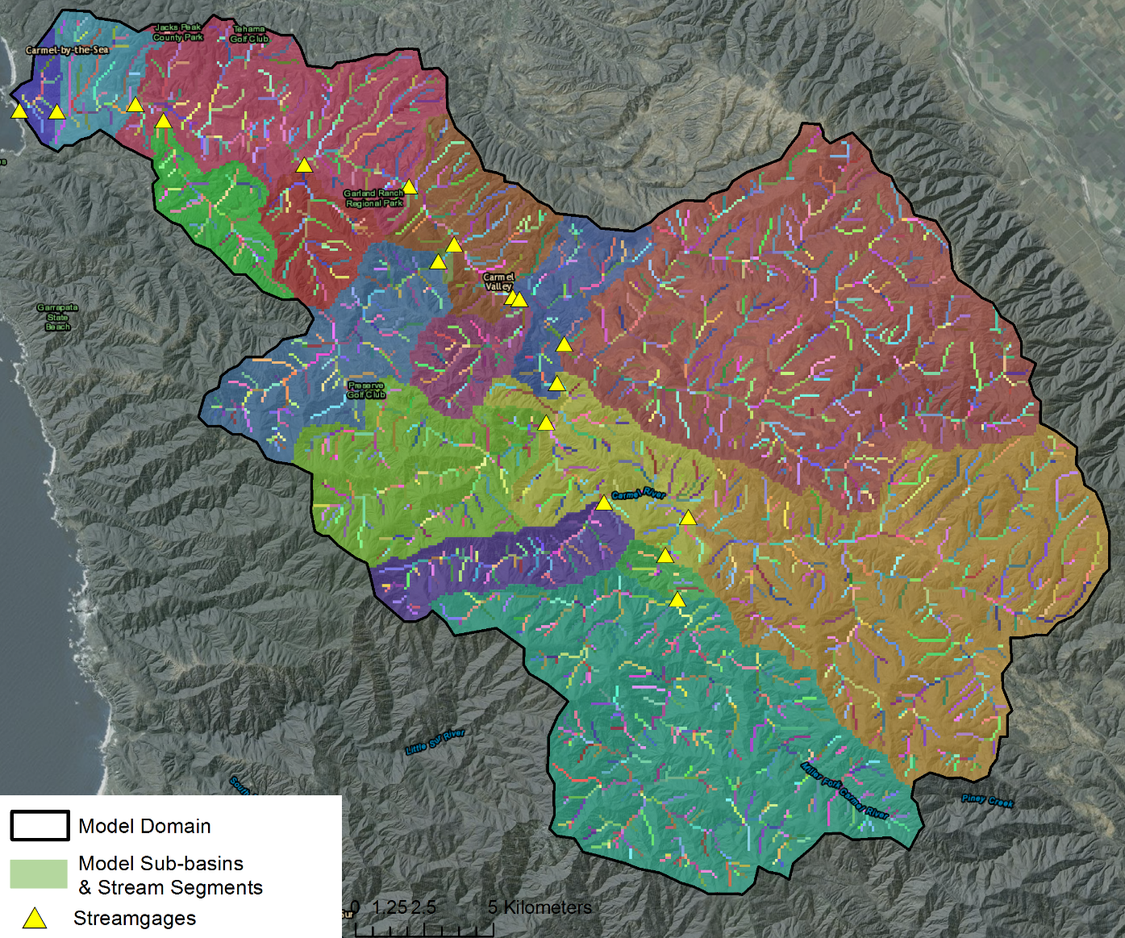

Figure 8. Spatial distribution of model sub-basins and stream segments. Sub-basin and stream cell colors represent unique sub-basins (n=17) and stream segments (n=2437).

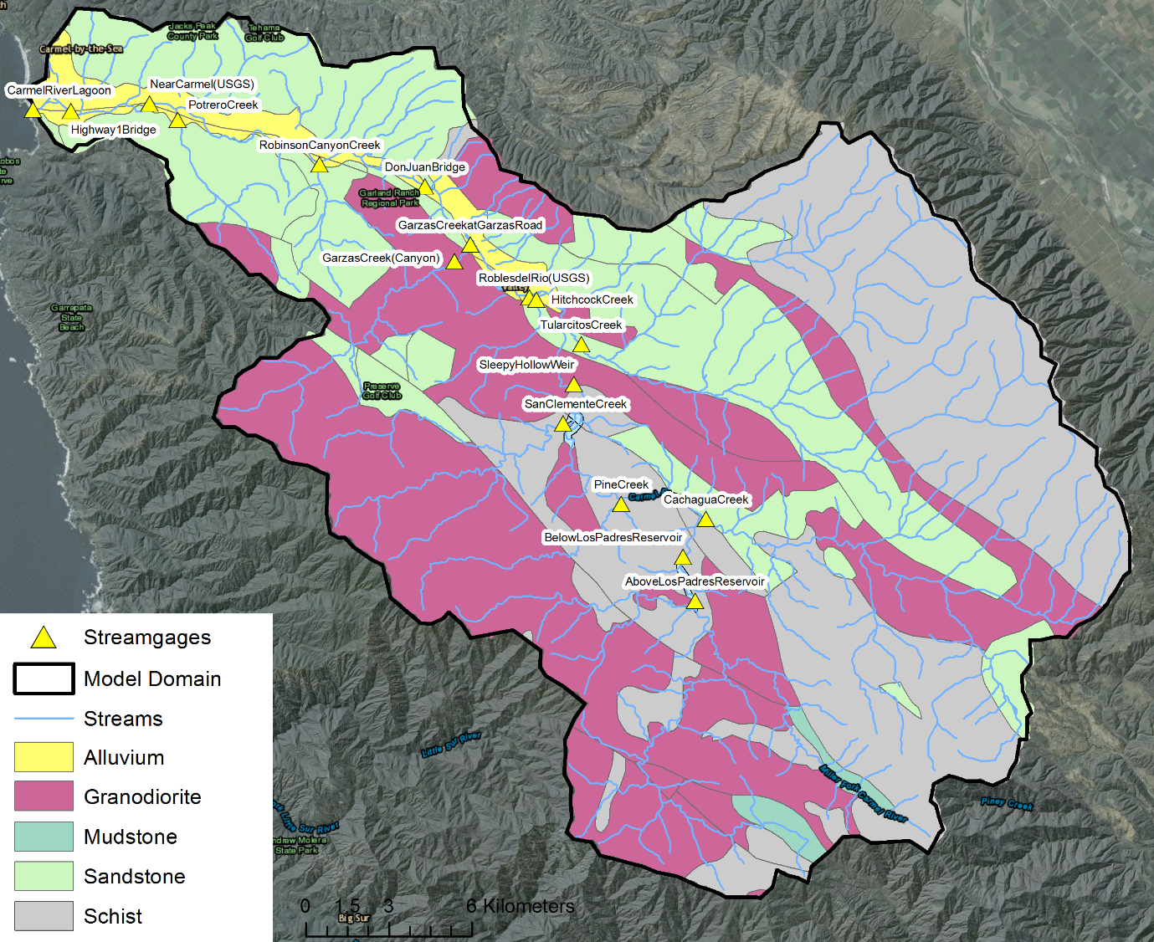

Figure 9. Surficial geology map of Carmel River basin. Digital geology map adopted from Ludington et al. (2007).

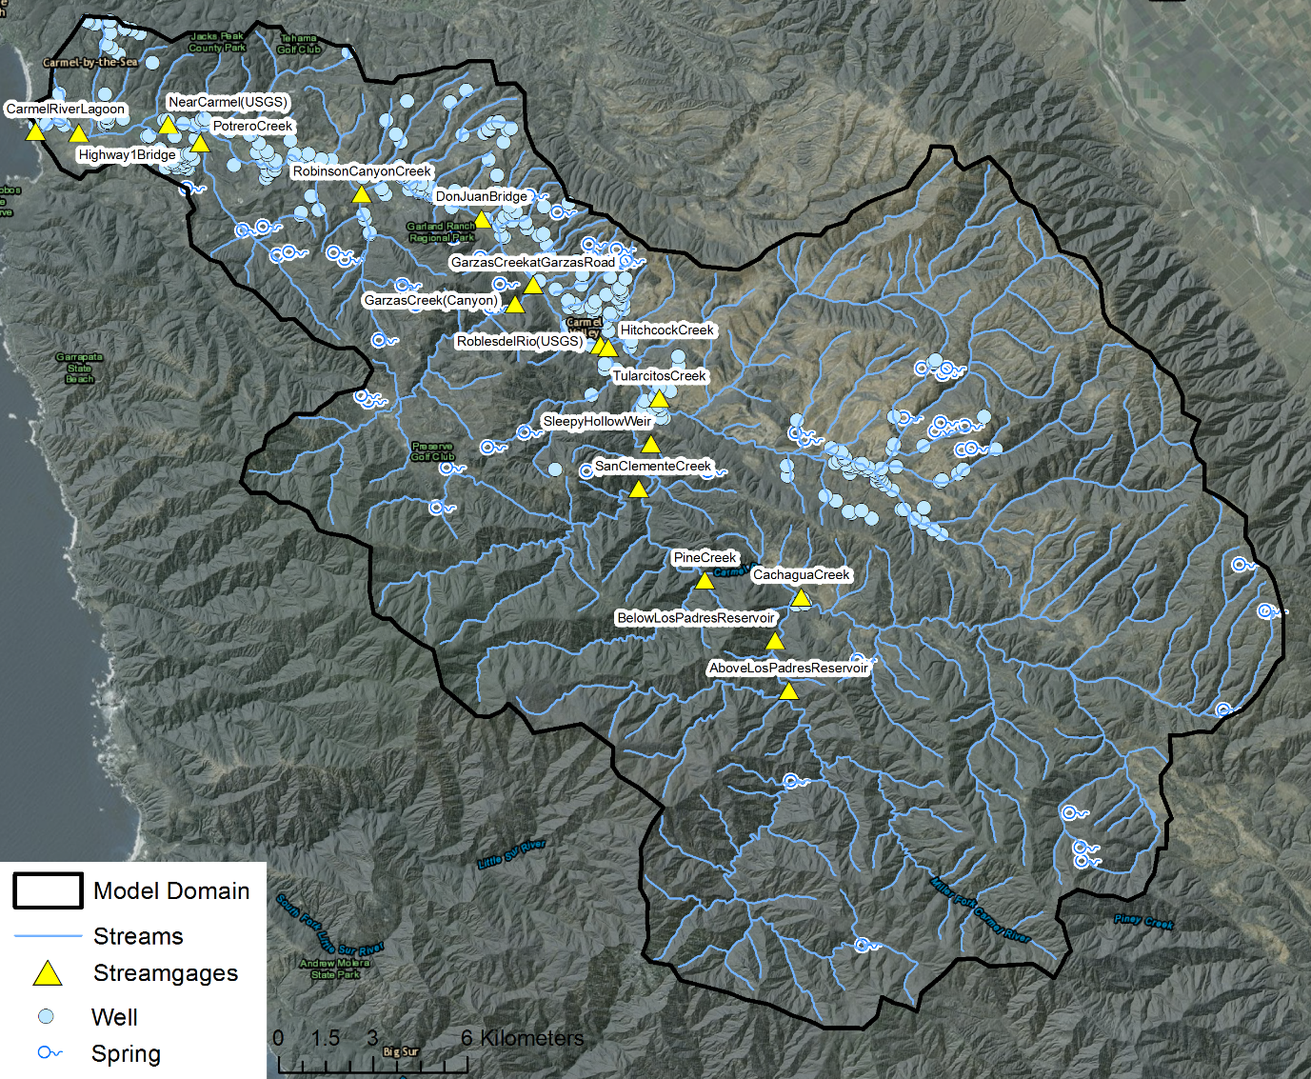

Figure 10. Surficial geology map of Carmel River basin and distribution of wells and spring information used for developing the HFM and water level observation dataset.

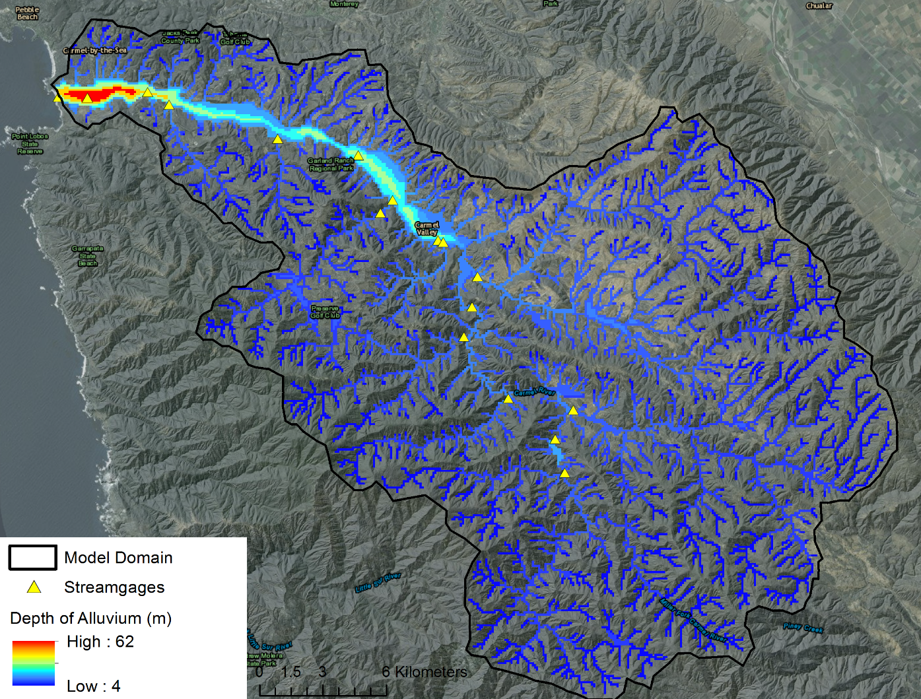

Figure 11. Depth of alluvium developed from combining previous study mapping (Logan, 1983a) with HFM database and conceptual model information.

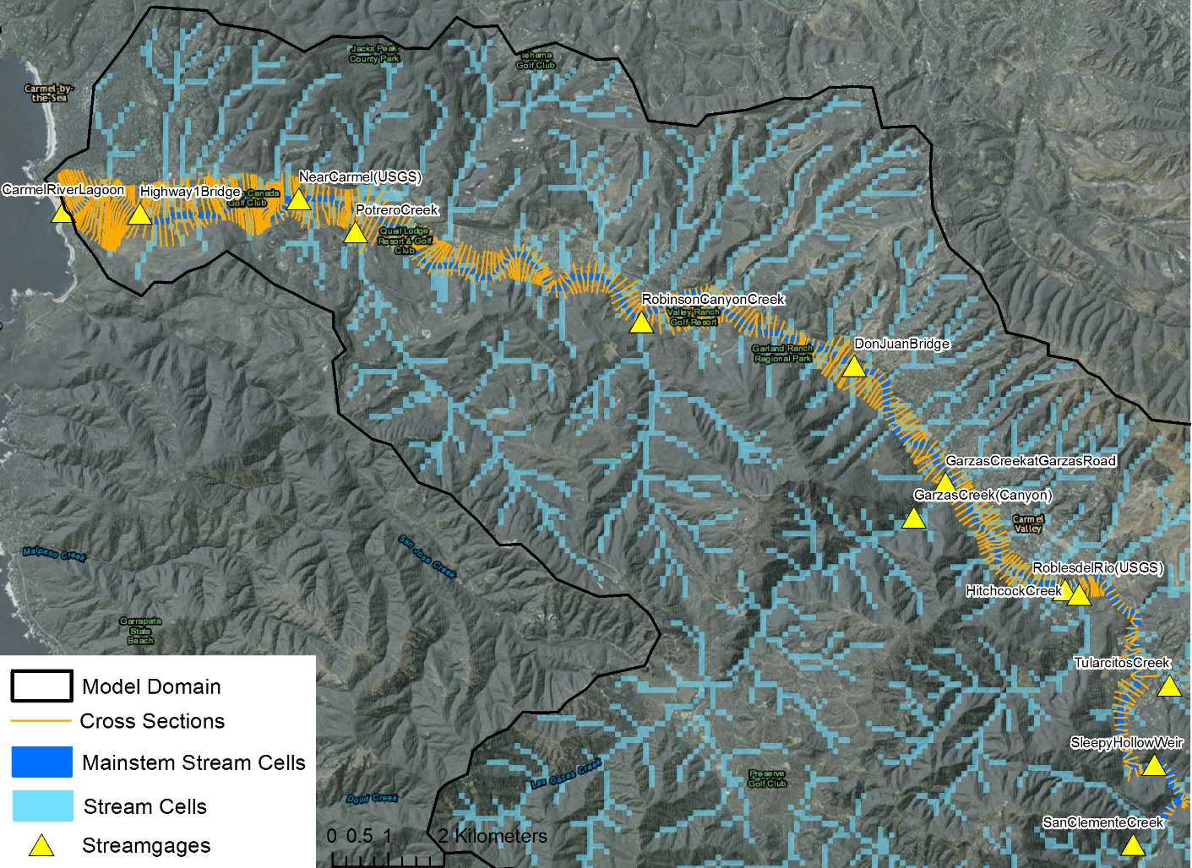

Figure 12. Channel survey cross sections used to develop tabulated values relating stream depth to width to flow for each mainstem SFR2 stream segment.